BANK LOAN REPORT QUERY DOCUMENT
A.BANK LOAN REPORT | SUMMARY
KPI’s:
- Total Loan applications:
select count(id) as Total_loan_application from Bank_Loan_data;
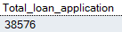
- MTD Loan applications:
select count(id) as MTD_Total_loan_application from Bank_Loan_data
WHERE MONTH(ISSUE_DATE) = 12;
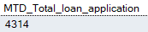
- PMTD Loan applications:
select count(id) as PMTD_Total_loan_application from Bank_Loan_data
WHERE MONTH(ISSUE_DATE) = 11;
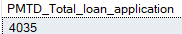
------------------------------------------------------------------------------------------------
- Total funded amount:
select sum(loan_amount) as Total_funded_amount from
Bank_Loan_data;
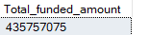
- MTD Total funded amount:
select sum(loan_amount) as Total_funded_amount fromBank_Loan_data
where month(issue_date) = 12;
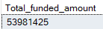
- PMTD Total funded amount:
select sum(loan_amount) as Total_funded_amount fromBank_Loan_data
where month(issue_date) = 11;
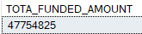
-----------------------------------------------------------------------------------------------------
- Total amount received:
select sum(total_payment) as Total_payment_received from Bank_loan_data;
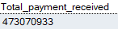
- MTD Total amount received:
select sum(total_payment) as Total_payment_received from Bank_loan_data where month(issue_date) = 12;
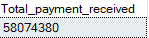
- PMTD Total amount received:
select sum(total_payment) as Total_payment_received from Bank_loan_data where month(issue_date) = 111;
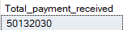
------------------------------------------------------------------------------------------------
- Average Interest rate:
select Round(avg(int_rate),5)*100 as Avg_int_rate from Bank_Loan_Data
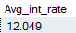
- MTD Average Interest rate:
select Round(avg(int_rate),5)*100 as Avg_int_rate from Bank_Loan_Data
where month(issue_date) = 12;
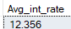
- PMTD Average Interest rate:
select Round(avg(int_rate),5)*100 as Avg_int_rate from Bank_Loan_Data
where month(issue_date) = 11;
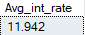
------------------------------------------------------------------------------------------------
- Average DTI:
select Round(avg(dti),5)*100 as Avg_Dti from Bank_Loan_Data
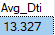
- MTD Average DTI:
select Round(avg(dti),5)*100 as Avg_Dti from Bank_Loan_Data
where month(issue_date) = 12;
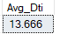
- PMTD Average DTI:
select Round(avg(dti),5)*100 as Avg_Dti from Bank_Loan_Data where month(issue_date) = 11;
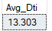
------------------------------------------------------------------------------------------------
GOOD LOAN ISSUED
- Good loan percentage
select (count(case when loan_status = 'Fully Paid' or loan_status = 'Current' Then id End)*100)/ count(id) as Good_loan_percentage from Bank_loan_data;
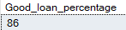
- Good loan application
select count(id) as Good_loan_application from Bank_loan_data
where loan_status = 'Fully Paid' or loan_status = 'Current';
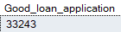
- Good loan funded amount
select sum(loan_amount) as Good_loan_funded_amount from Bank_loan_data
where loan_status = 'Fully Paid' or loan_status = 'Current';
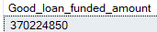
- Good loan amount received
select sum(total_payment) as Good_loan_received_amount from Bank_loan_data where loan_status = 'Fully Paid' or loan_status = 'Current';
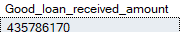
-----------------------------------------------------------------------------------------------------------------
BAD LOAN ISSUED
- Bad loan percentage
select (count(case when loan_status = 'Charged Off' Then id End)*100)/ count(id) as bad_loan_percentage from Bank_loan_data;
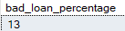
- Bad loan application
select count(loan_status) as Bad_loan_application from Bank_loan_data
where loan_status = 'Charged Off';
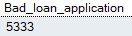
- Bad loan funded amount
select sum(loan_amount) as Bad_loan_funded_amount from Bank_loan_data
where loan_status = 'Charged Off';
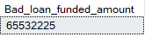
- Bad loan amount received
select sum(total_payment) as Bad_loan_amount_received from Bank_loan_data
where loan_status = 'Charged Off';
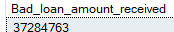
-----------------------------------------------------------------------------------------------------------------

LOAN STATUS
select loan_status,
count(id) as Loan_count,
sum(Total_payment) as Total_amount_received,
sum(loan_amount) as Total_funded_amount,
Avg(int_rate)*100 as Avg_intrest_rate,
Avg(dti)*100 as Avg_Dti
from Bank_loan_data
Group by loan_status;
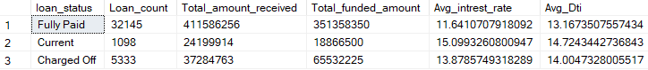
select loan_status,
sum(loan_amount) as MTD_Total_funded_amount,
sum(Total_payment) as MTD_Total_payment_received
from Bank_loan_data
where month(issue_date) = 12
Group by loan_status;
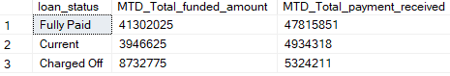

B. BANK LOAN REPORT | OVERVIEW
MONTH
select
month(issue_date) as Month_number,
Datename(Month, issue_date) as Months,
count(id) as No_of_aplications,
sum(loan_amount) as Total_funded_amount,
sum(total_payment) as Total_amount_received
from Bank_loan_data
group by month(issue_date), Datename(Month, issue_date)
order by month(issue_date);
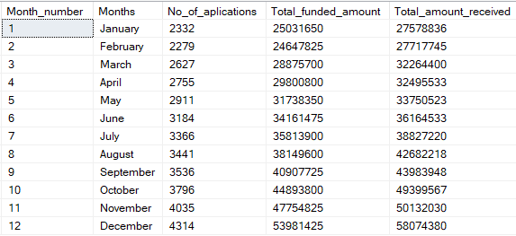

STATE
select
address_state as State,
count(id) as No_of_applications,
sum(loan_amount) as Total_funded_amount,
sum(total_payment) as Total_amount_received
from bank_loan_data
Group by address_state
order by address_state;
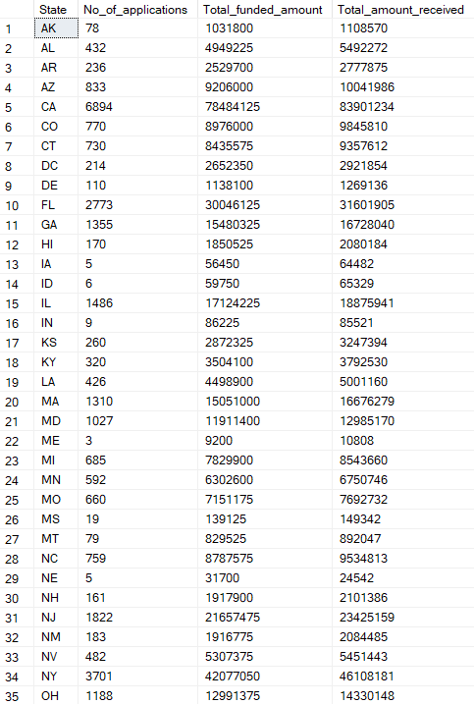
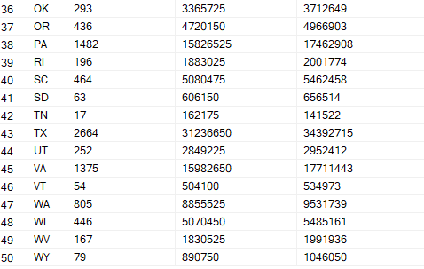

TERM
select term,
sum(loan_amount) as Total_funded_amount,
sum(Total_payment) as Total_amount_received
from Bank_loan_data
Group by term
order by term;
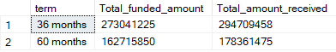

EMPLOYEE LENGTH
select emp_length,
count(id) as Total_application,
sum(loan_amount) as Total_funded_amount,
sum(Total_payment) as Total_amount_received
from Bank_loan_data
Group by emp_length
order by emp_length;
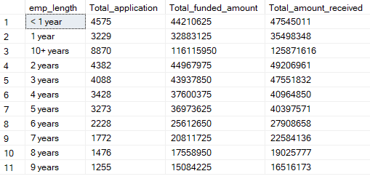

PURPOSE
select purpose,
count(id) as Total_application,
sum(loan_amount) as Total_funded_amount,
sum(Total_payment) as Total_amount_received
from Bank_loan_data
Group by purpose
order by purpose;

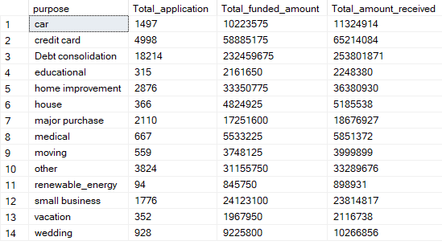
HOME OWNERSHIP
select home_ownership,
count(id) as Total_application,
sum(loan_amount) as Total_funded_amount,
sum(Total_payment) as Total_amount_received
from Bank_loan_data
Group by home_ownership
order by home_ownership;
